**Team 1 DSD Project**

In our project, we designed a model for a wheelchair that moves automatically, avoids obstacles, and stops when it is unable to avoid. The model wheelchair consists of two motors, an H bridge, two proximity IR sensors, and one motion and heat IR sensor. When the two proximity IR sensors both detect an obstacle at the same time, the wheelchair stops and the buzzer is sent a signal to activate. If the left sensor detects motion, the wheelchair avoids it by going right (by stopping the right wheel motor). The right sensor works in the same way. When the motion and heat IR sensor detects a living organism, the LED is sent a signal which lights it up.

For the software implementation, we used the VHDL language on the Quartus Prime Lite program. Our code had one main entity and no sub entities. The main entity (sensscar2) had the following inputs as std_logic datatype: sensorleft, sensorright, switch, and Hsensor. The inputs sensorleft and sensorright are for the left and right PIR sensors accordingly. The two sensors are active low, which means that when the inputs are ‘1’, the sensors detect nothing, and when the inputs are ‘0’, the sensors detect an obstacle. The motion and heat IR sensor is active high, so when the Hsensor signal is ‘1’, it means that the sensor detects a living organism, and when it is ‘0’, it detects nothing. The switch is for the first switch on the FPGA. As for the outputs, they were set as signals and were of type std_logic, the same type as the inputs. They were: goR, stopR, goL, stopL, Lout, and buzz. The goR, goL, stopR, stopL signals are related to the motor(which is active high), when the goR is ‘1’ the right motor will activate, and when it is ‘0’, the motor will not activate. The goL will work in the same way. The stopL and the stopR signals stop the wheels when the go signals are ‘0’.

The architecture of the entity sensscar2 contains two processes, one named “sensors” and another named “motion”. The first process “sensors” handles the movement of the car as well as the signals related to the sensors. There are if conditions that handle every case where either of the PIR sensors detects an obstacle or not, and as such the process operates the motors accordingly. The second process “motion” handles the cases where the heat and motion IR sensor detects a living organism, and turns on the LED bulb accordingly.

The pin assignments are as follows:

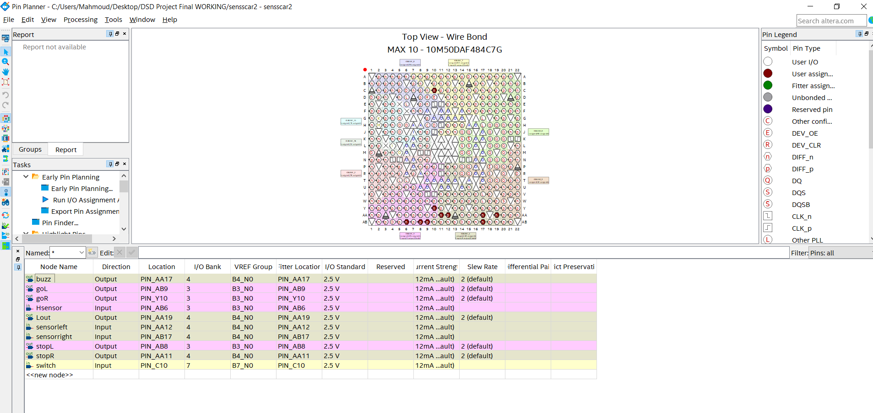

“Team 1” members:

Ziad Yehia Elwakil 43-5530

Mahmoud Ahmed Magdy 43-5787

Youssef Khaled Farahat 43-3897

Mohammad Hesham 43-4373

Ali Mohamad Salah 43-4025

Toqa Mahmoud 43-9120